Session 4
Task1:
Create a table called Playlist with columns: id, song_name, artist, genre, and play_count. Insert at least 5 sample records representing your favorite songs from Spotify.
Query

CREATE TABLE Playlist (
id INT AUTO_INCREMENT PRIMARY KEY,
song_name VARCHAR(100),
artist VARCHAR(100),
genre VARCHAR(50),
play_count INT
); 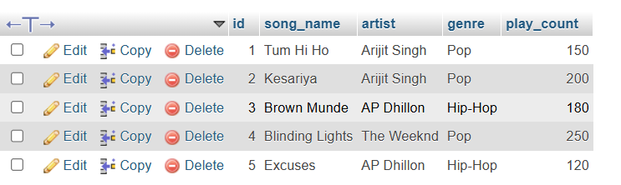
Task 2:

Write a SELECT query to display only the song_name and artist from the Playlist table, but show the artist column as 'Singer' using an alias.
Query

SELECT song_name, artist AS Singer
FROM Playlist;
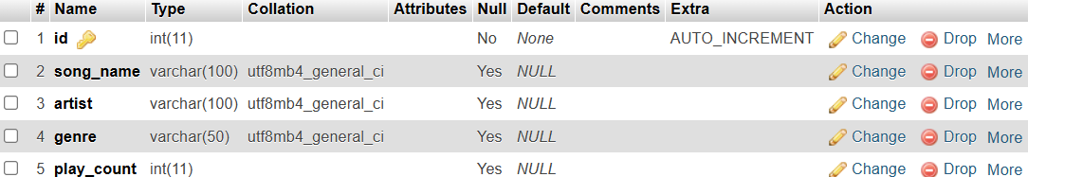

Task 3:

Write a SELECT query to find all songs in the Playlist table where the genre is 'Pop' and play_count is greater than 100. Sort the results by play_count in descending order.
Query

SELECT *
FROM Playlist
WHERE genre = 'Pop'
AND play_count > 100
ORDER BY play_count DESC;
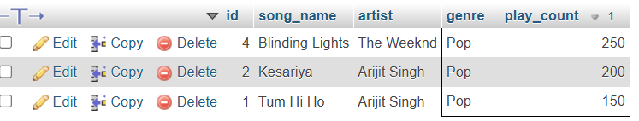

Task 4:
Use the COUNT aggregate function to find out how many songs in your Playlist table belong to the genre 'Hip-Hop'.
Query

SELECT COUNT(*) AS total_songs
FROM Playlist
WHERE genre = 'Hip-Hop
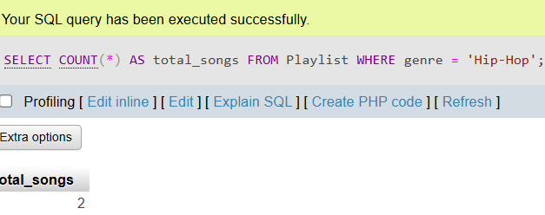op';

Task 5:
Write a SELECT query that shows the total number of plays (SUM of play_count) for each genre in your Playlist table, grouped by genre.<br><br><em><strong>Hint:</strong> Use GROUP BY with the SUM function to aggregate play counts by genre.</em>
Query

SELECT genre, SUM(play_count) AS total_plays
FROM Playlist
GROUP BY genre;


